Installation Prerequisites for .NET Development
1: Install Visual Studio 2026 IDE – For .NET Structural/Standard Projects Development
Download Visual Studio 2026 setup file using following URL and install it.
https://visualstudio.microsoft.com/downloads/
As the installation process begins, the Visual Studio Installer dialog will prompt you to select the required workloads. Please select the following options based on our project development requirements:
- .NET desktop development → Console, Windows Forms, WPF, etc.
- ASP.NET and web development → ASP.NET Core/Web APIs
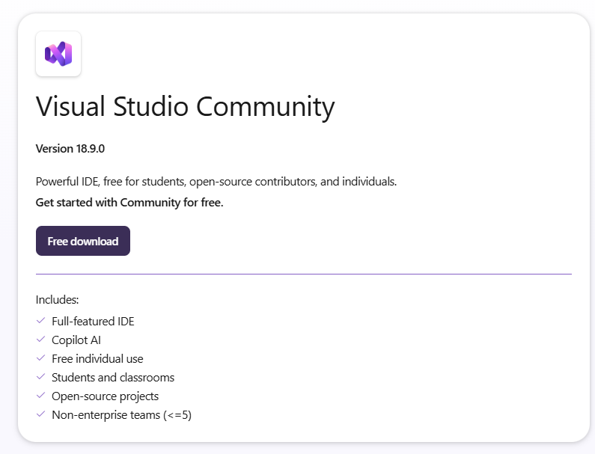

The IDE will also install the latest .NET SDK version 10.0 along with other .NET runtime Frameworks.
To check latest installed .NET SDK versions, you can run following command (on Windows Command Prompt):
- dotnet --version
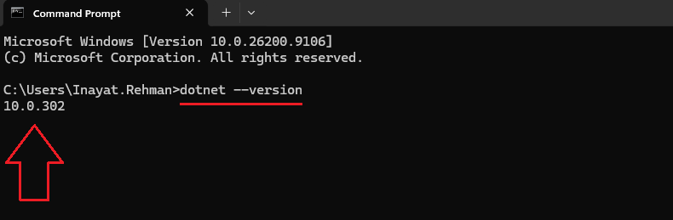
To check all installed .NET SDKs and Runtimes Frameworks, you can run the following command (on Windows Command Prompt):
- dotnet –list-sdks
- dotnet --list-runtimes
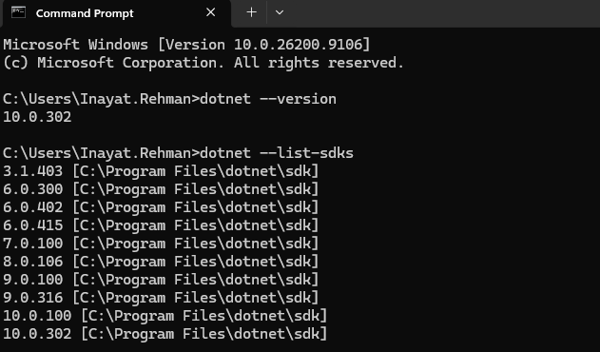
If someone already has already installed the previous version of Visual Studio 2022/2019 then they can only install .NET SDK 10 only:
Open the following URL and click the mentioned-link in the screen-shot below:
https://dotnet.microsoft.com/en-us/download/dotnet/10.0
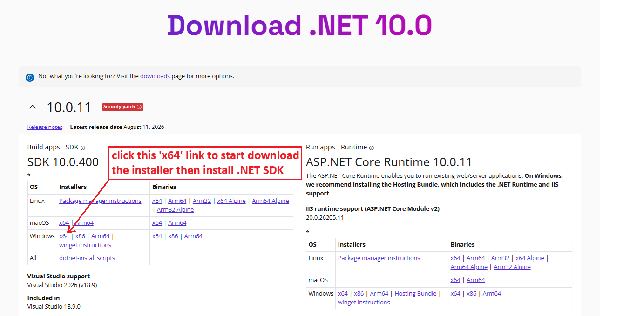

2: For Local Database Connectivity and Access
Install DBeaver client software for SQLite database connectivity and access, which we will use in our projects. SQLite Database supports most standard database requirements similar to Microsoft SQL Server while being local, lightweight, and easy to use.

GIT Commands
They are as under:
GIT Commands - echo "# CSharp Training Session Solutions" >> README.md
git init
git add .
git commit -m "first commit"
git branch -M main
git remote add origin https://github.com/inayat68/CSharpTrainingSessionSolutions.git
git push -u origin main
git pull origin main

